Roscommon County Council: Library Services

Comhairle Chontae Ros Comáin: Seirbhísí Leabharlainne

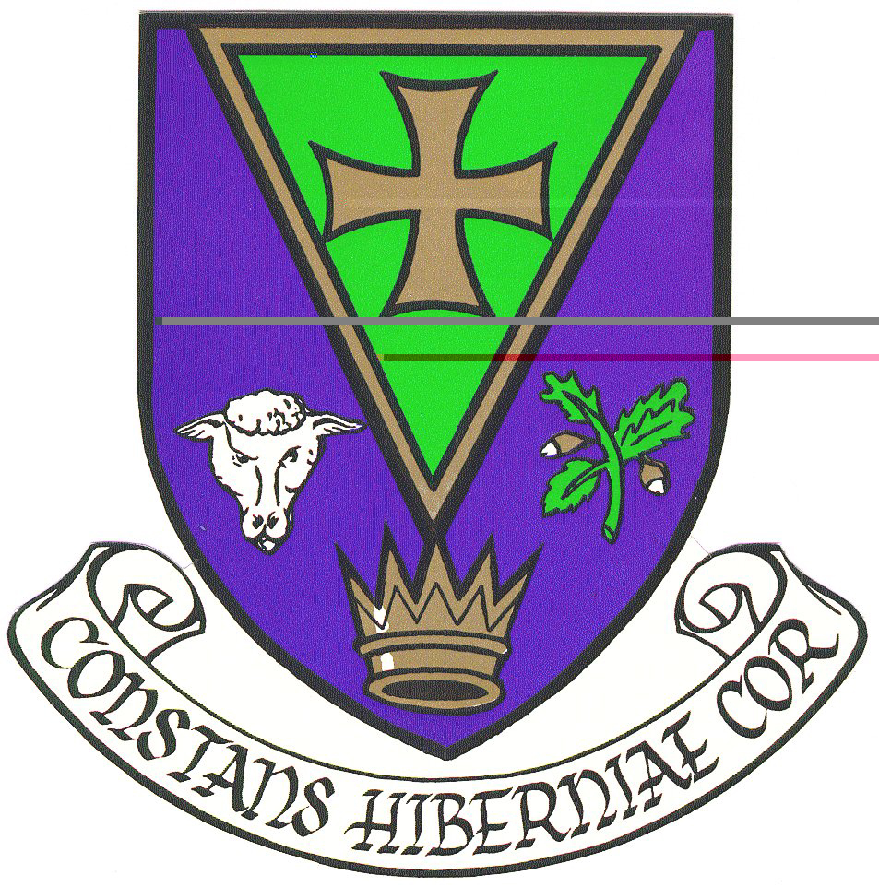

Summer Events Programme 2010

Copies of the programme with dates, location, times and details of specific age group suggested for events are available through the Library Services. Those wishing to attend or book places are asked to contact the individual service points listed below. Please note that places are limited in terms of facilitation and local conditions up to a maximum of 20. The activities are targeted for the 5 to 10 year age group. Parents are asked not to leave children unattended in the Library while events are in progress and must check and clarify policies with the individual branches

Roscommon County Library Ph: 090-66-37277
Ballaghaderreen Library Ph: 094-98-77044
Boyle Library Ph: 071-96-62800
Castlerea Library Ph 094-96-20745

Programme also available on Library link at www.roscommoncoco.ie

Wednesday 7th July Imagination Gym Workshops; Interactive children’s stories with music, art, folklore and nature
Roscommon County Library 2.00 - 3.00 and 3.30 - 4.30 (first workshop for children, 2nd for children and parent/guardian).

Thurs 8th July Imagination Gym Workshops: Interactive children’s stories with music, art, folklore and nature
Ballaghaderreen Library 2.00 - 3.00 and 3.30 - 4.30

Friday 9th July Imagination Gym Workshops: Interactive children’s stories with music, art, folklore and nature
Imagination Gym Workshops: Interactive children’s stories with music, art, folklore and nature
Castlerea Library 10.30 - 11.30 and 12.00 - 1.00
Boyle Library 2.00 - 3.00 and 3.30 - 4.30

